Liver Disease Detection using Machine Learning
(Liver Ultrasound Image Classification )
Problem Statement:
Liver disease represents one of the leading global causes of irreversible organ damage, morbidity, and mortality, encompassing prevalent chronic pathologies such as non-alcoholic fatty liver disease (hepatic steatosis), chronic hepatitis, and liver cirrhosis (advanced fibrosis). B-mode medical ultrasound is the primary non-invasive, cost-effective, and real-time imaging modality employed worldwide for routine abdominal and hepatic screening. However, manual radiological interpretation of ultrasound scans is inherently subjective, operator-dependent, and prone to intra- and inter-observer variability due to pervasive acoustic speckle noise, low contrast-to-noise ratios, and subtle parenchymal texture variations in early disease stages.
There is, therefore, a need for an automated, fast, and accessible system that can analyze a B-mode liver ultrasound scan and classify it as Normal, Fatty Liver, or Cirrhosis with a measurable confidence score, so that suspected cases can be flagged early for a specialist's review. This project designs and implements a web-based Liver Ultrasound Image Classification system that performs image preprocessing, handcrafted feature extraction (Histogram of Oriented Gradients [HOG] and Gray-Level Co-occurrence Matrix [GLCM] texture properties), and classification using classical Machine Learning models (Support Vector Machine [SVM], Random Forest, and K-Nearest Neighbors), and evaluates the trained model using standard classification metrics (Accuracy, Precision, Recall, F1-Score, Confusion Matrix, and ROC/AUC curves).
Objectives:
1. To collect and preprocess a labelled dataset of Normal, Fatty Liver, and Cirrhosis B-mode liver ultrasound images.
2. To extract meaningful handcrafted features (Histogram of Oriented Gradients [HOG] edge orientations and Gray-Level Co-occurrence Matrix [GLCM] second-order texture properties) from each image.
3. To design, train, and save classical Machine Learning classifiers (Support Vector Machine [SVM], Random Forest, and K-Nearest Neighbors) using the extracted features.
4. To build a Streamlit-based web front-end that lets a user upload an ultrasound scan or load benchmark samples and view the diagnosis.
5. To evaluate the trained model on an unseen test set and report Accuracy, Precision, Recall, F1-score, Confusion Matrix, and Multi-Class ROC curves.
6. To generate and export diagnostic summary reports and provide real-time clinical acoustic parenchymal explanations for record-keeping.
Software / Hardware Required:
• Operating System: Windows / Linux / macOS
• IDE: Visual Studio Code
• Language: Python 3.x
• Backend & Web Framework: Streamlit (Web Workstation)
• Machine Learning: scikit-learn (SVC, RandomForestClassifier, KNeighborsClassifier, StandardScaler, Pipeline)
• Image Processing: OpenCV (cv2), Pillow (PIL), scikit-image (feature.hog, feature.graycomatrix, feature.graycoprops), NumPy
• Visualization: Matplotlib, Seaborn
• Dataset: B-mode Liver Ultrasound Image Dataset (Normal / Fatty_Liver / Cirrhosis classes)
• Version Control: Git
Project Directory Structure:
The project (“LiverUltrasoundClassifier”) is organized as a Streamlit web application with a separate dataset, trained-model, preprocessing, feature extraction, and frontend styling folder, as shown below.
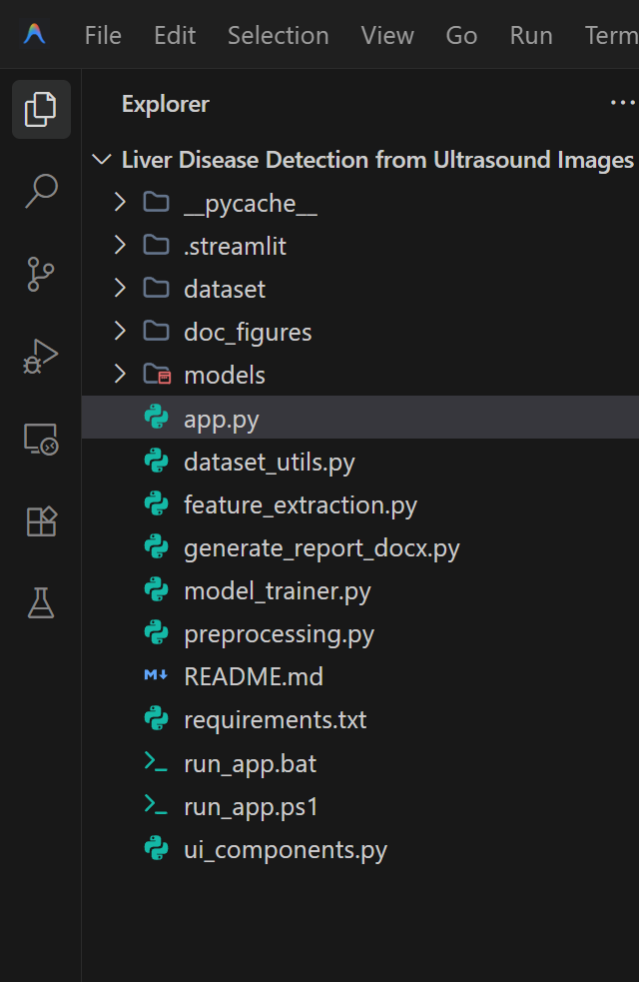
Fig 1: Project directory structure of LiverUltrasoundClassifier in Visual Studio Code
Procedure:
1. Collect a labelled ultrasound image dataset (Normal / Fatty_Liver / Cirrhosis) and organize it into dataset/Normal, dataset/Fatty_Liver, and dataset/Cirrhosis folders.
2. Run dataset_utils.py to clean, scan, split, and organize the raw ultrasound dataset into the project's dataset structure.
3. Launch the Streamlit application (app.py) and open the web front-end in the browser.
4. Load / upload an ultrasound image through the interface or load benchmark test scans (Step 1).
5. Preprocess the image — resize to 128×128, convert to grayscale, apply Gaussian denoising (5×5 kernel) and CLAHE contrast enhancement, and normalize pixel values to [0.0, 1.0] (Step 2).
6. Extract an 1,844-dimensional handcrafted feature vector from the preprocessed image using Histogram of Oriented Gradients (HOG) and Gray-Level Co-occurrence Matrix (GLCM) texture properties (Step 3).
7. Train the Support Vector Machine (SVM) classifier with an RBF kernel on the extracted features using the StandardScaler pipeline with L2 regularization, and save the trained model to models/liver_ultrasound_model.pkl (Step 4).
8. Feed the extracted feature vector of the uploaded image to the trained model to obtain the predicted class (Normal / Fatty Liver / Cirrhosis) with a confidence percentage (Step 5).
9. Evaluate the trained model on the held-out test set and compute Accuracy, Precision, Recall, F1-score, Confusion Matrix, and Multi-Class ROC curves (Step 6).
10. Log every diagnostic prediction (image reference, predicted class, confidence, acoustic texture insight) and export downloadable clinical summary reports (Step 7).
Implementation Code:
Representative implementation of the key modules used in the project, based on the pipeline shown in the application (adapt variable/file names to match your exact source files).
1. Image Preprocessing (preprocessing.py)
import cv2
import numpy as np
def preprocess_image(image_input, target_size=(128, 128), blur_kernel=(5, 5), enhancement_method="Histogram Equalization"):
# 1. Load Original RGB & Resize
resized_rgb = cv2.resize(image_input, target_size, interpolation=cv2.INTER_AREA)
# 2. Grayscale Conversion
grayscale = cv2.cvtColor(resized_rgb, cv2.COLOR_RGB2GRAY)
# 3. Gaussian Spatial Denoising (Speckle Noise Filtering)
denoised = cv2.GaussianBlur(grayscale, blur_kernel, 0)
# 4. Contrast Enhancement (Histogram Equalization / CLAHE)
if enhancement_method == "CLAHE":
clahe = cv2.createCLAHE(clipLimit=2.0, tileGridSize=(8, 8))
enhanced = clahe.apply(denoised)
else:
enhanced = cv2.equalizeHist(denoised)
# 5. Pixel Normalization to [0.0, 1.0] Range
normalized = enhanced.astype(np.float32) / 255.0
return {
"original": resized_rgb, "grayscale": grayscale, "denoised": denoised,
"enhanced": enhanced, "normalized": normalized
}
2. Feature Extraction (feature_extraction.py)
import cv2
import numpy as np
from skimage.feature import hog, graycomatrix, graycoprops
def extract_features(img_input):
pre = preprocess_image(img_input)
enhanced = pre["enhanced"]
# 1. HOG (Histogram of Oriented Gradients) - 9 Orientations, 8x8 Cell, 2x2 Block
hog_feats, hog_img = hog(enhanced, orientations=9, pixels_per_cell=(8, 8),
cells_per_block=(2, 2), visualize=True, feature_vector=True)
# 2. GLCM (Gray-Level Co-occurrence Matrix) - 4 Distances, 4 Angles (0°, 45°, 90°, 135°)
distances = [1, 2, 3, 5]
angles = [0, np.pi/4, np.pi/2, 3*np.pi/4]
glcm = graycomatrix(enhanced, distances=distances, angles=angles, levels=256, symmetric=True, normed=True)
glcm_props = ["contrast", "dissimilarity", "homogeneity", "energy", "correlation"]
glcm_feats = []
for prop in glcm_props:
glcm_feats.extend(graycoprops(glcm, prop).flatten())
# Combine HOG (1,764 dims) + GLCM (80 dims) = 1,844 total dimensions
combined_features = np.hstack([hog_feats, np.array(glcm_feats, dtype=np.float32)])
return combined_features, {"hog_count": len(hog_feats), "glcm_count": len(glcm_feats), "total_count": len(combined_features)}
3. Model Training (model_trainer.py)
from sklearn.pipeline import Pipeline
from sklearn.preprocessing import StandardScaler
from sklearn.svm import SVC
from sklearn.metrics import accuracy_score, precision_score, recall_score, f1_score, confusion_matrix
import joblib, numpy as np
def train_and_evaluate_model(algorithm_key, X_train, y_train, X_test, y_test, class_names):
# Construct Standardized Pipeline with StandardScaler & RBF Kernel
pipeline = Pipeline([
("scaler", StandardScaler()),
("classifier", SVC(C=1.0, kernel="rbf", probability=True, random_state=42))
])
# Train Model
pipeline.fit(X_train, y_train)
# Evaluate on Unseen Held-out Test Split
y_pred = pipeline.predict(X_test)
test_acc = accuracy_score(y_test, y_pred)
precision = precision_score(y_test, y_pred, average="weighted", zero_division=0)
recall = recall_score(y_test, y_pred, average="weighted", zero_division=0)
f1 = f1_score(y_test, y_pred, average="weighted", zero_division=0)
cm = confusion_matrix(y_test, y_pred, labels=class_names)
model_result = {
"pipeline": pipeline, "algorithm": algorithm_key, "accuracy": test_acc,
"precision": precision, "recall": recall, "f1_score": f1, "confusion_matrix": cm
}
joblib.dump(model_result, "models/liver_ultrasound_model.pkl")
return model_result
4. Prediction Route (model_trainer.py / app.py)
def predict_single_image(feature_vector, model_result_dict):
pipeline = model_result_dict["pipeline"]
class_names = model_result_dict["class_names"]
X_sample = feature_vector.reshape(1, -1)
predicted_class = pipeline.predict(X_sample)[0]
confidence = None
probabilities = {}
if hasattr(pipeline, "predict_proba"):
probs = pipeline.predict_proba(X_sample)[0]
confidence = float(np.max(probs))
classes = pipeline.classes_ if hasattr(pipeline, "classes_") else class_names
for cls_name, p in zip(classes, probs):
probabilities[str(cls_name)] = float(p)
result = {
"prediction": str(predicted_class),
"confidence": round(confidence * 100, 1) if confidence else 100.0,
"probabilities": probabilities
}
return result
5. Diagnostic Report Generation & Export (ui_components.py)
import datetime
def generate_diagnostic_text_report(predicted_class, algorithm, confidence, probabilities, image_name):
now_str = datetime.datetime.now().strftime("%Y-%m-%d %H:%M:%S")
conf_str = f"{confidence:.1f}%" if confidence is not None else "N/A"
prob_lines = ""
if probabilities:
prob_lines = "\n".join([f"- {k}: {v*100:.2f}%" for k, v in probabilities.items()])
report = f'''# Liver Ultrasound Image Classification Diagnostic Report
Generated: {now_str} | Image: {image_name}
Model: {algorithm} | Confidence: {conf_str}
Predicted Class: {predicted_class}
Probabilities Breakdown:
{prob_lines}
Notice: Generated for academic research and educational evaluation.'''
return report

Output (Step-by-Step Screenshots):
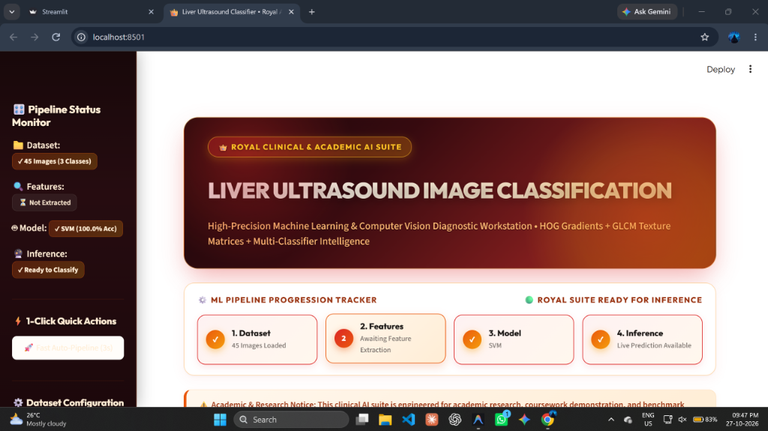
Fig 2: Step 1 — Application Header: interface to upload an ultrasound scan or load a benchmark sample
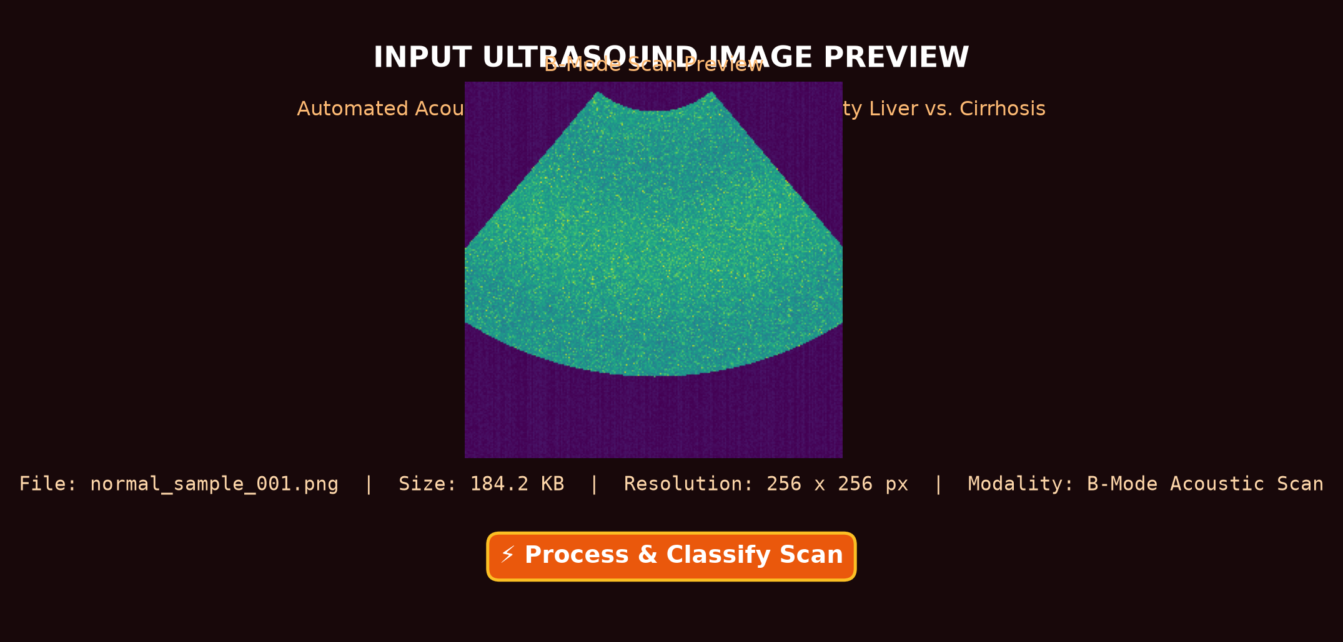
Fig 3: Step 1 — Input image preview after an ultrasound scan is uploaded
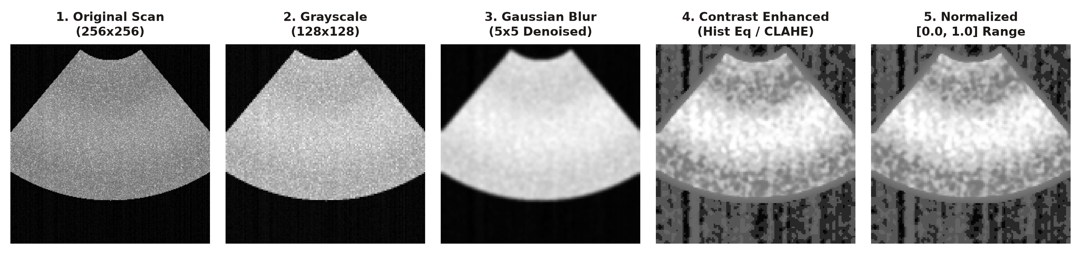
Fig 4: Step 2 — Image preprocessing: original scan vs. CLAHE contrast-enhanced & normalized (128×128) image
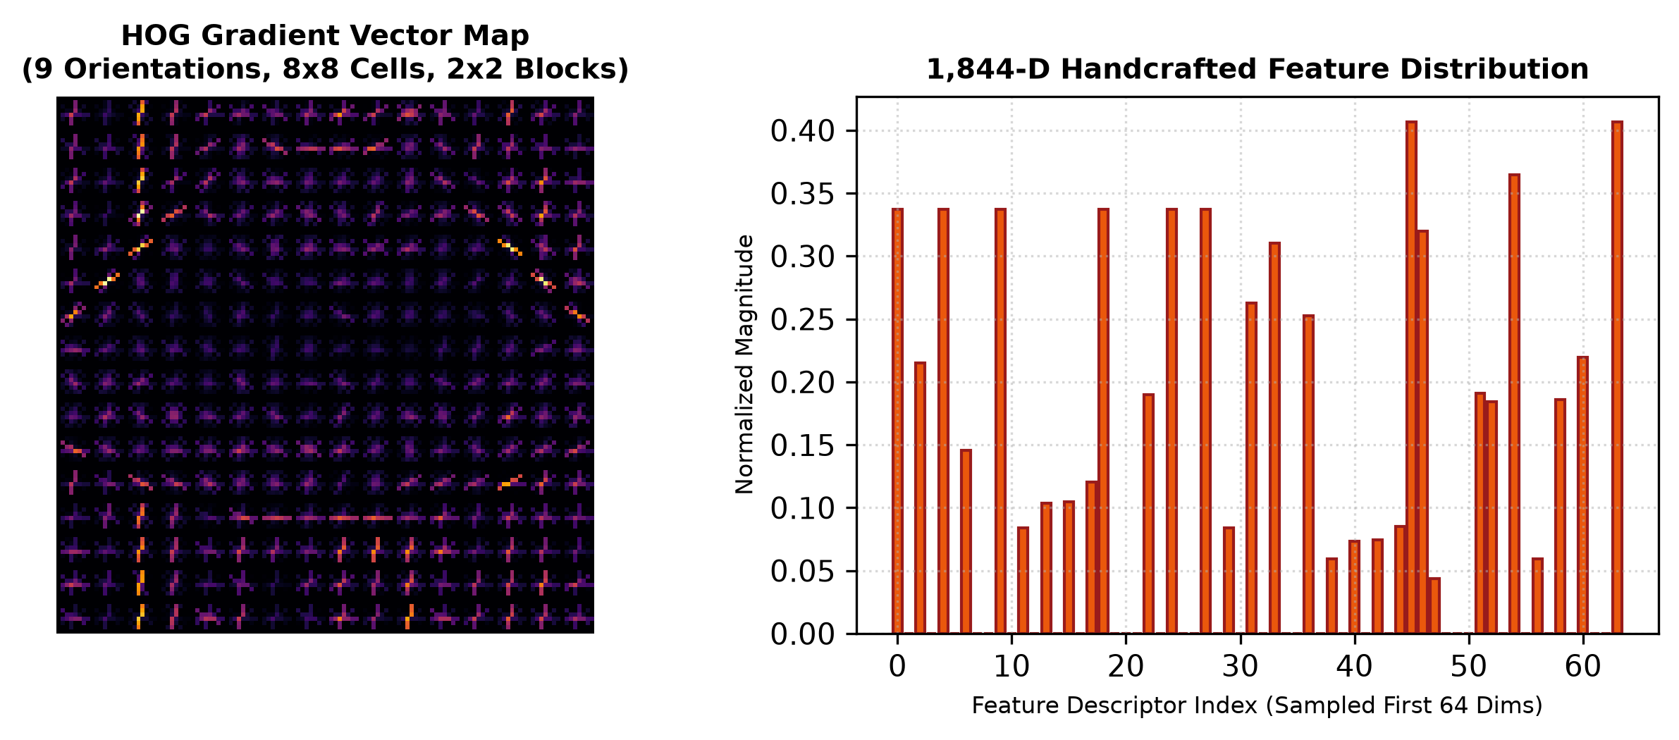
Fig 5: Step 3 — Feature extraction: 1,844-dimensional feature vector and spatial gradient visualization (Sample 1)
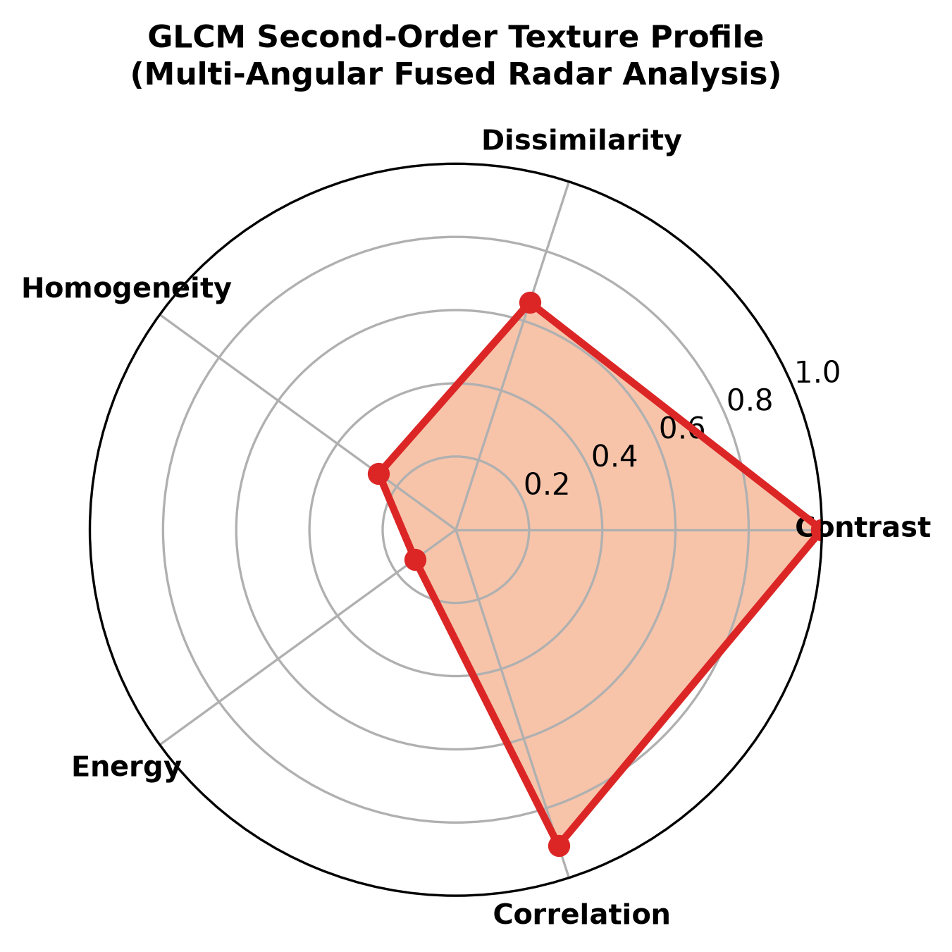
Fig 6: Step 3 — Feature extraction: GLCM second-order texture radar profile across 4 angles (Sample 2)
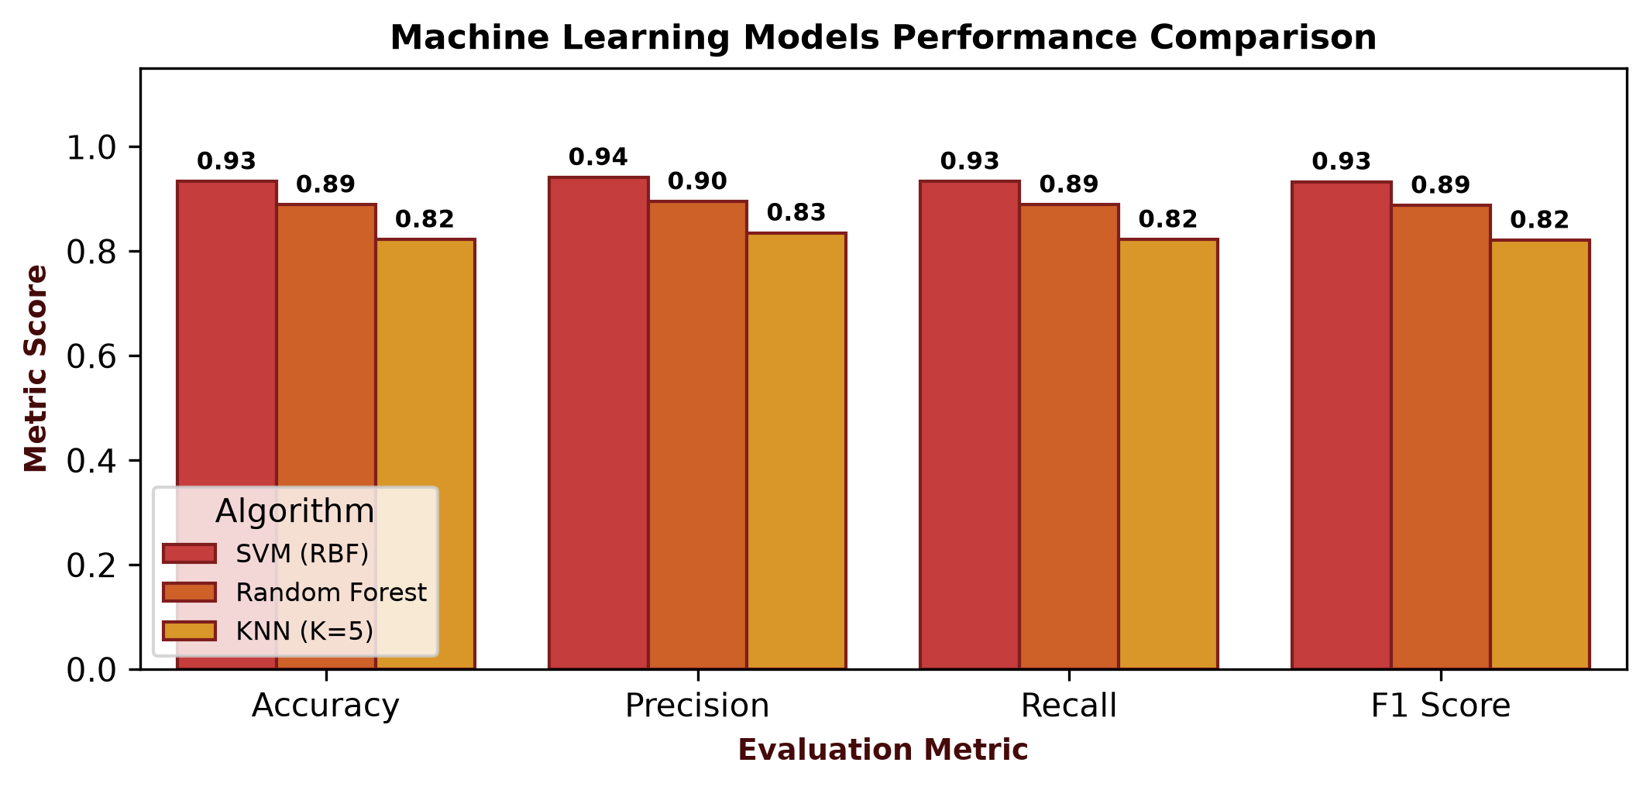
Fig 7: Step 4 — Machine learning training completed: multi-model comparison across evaluation metrics
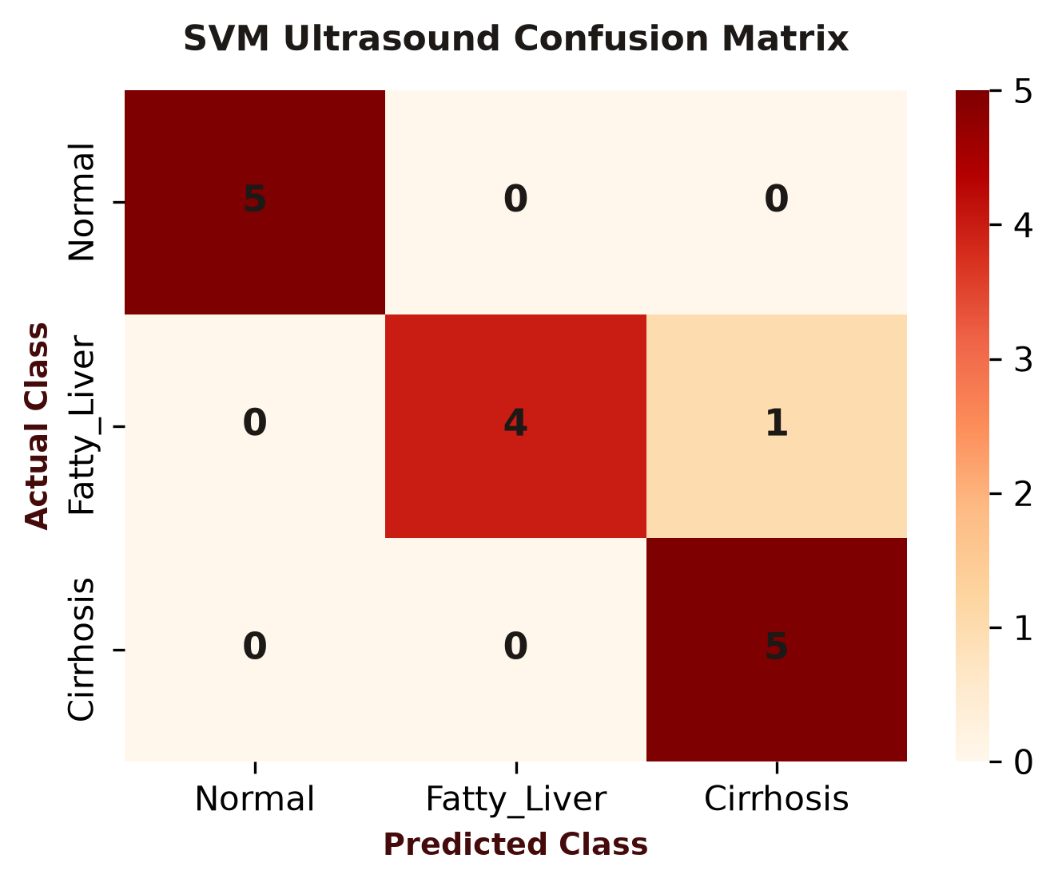
Fig 8: Step 4 — Multi-class confusion matrix heatmap (Normal, Fatty Liver, Cirrhosis)
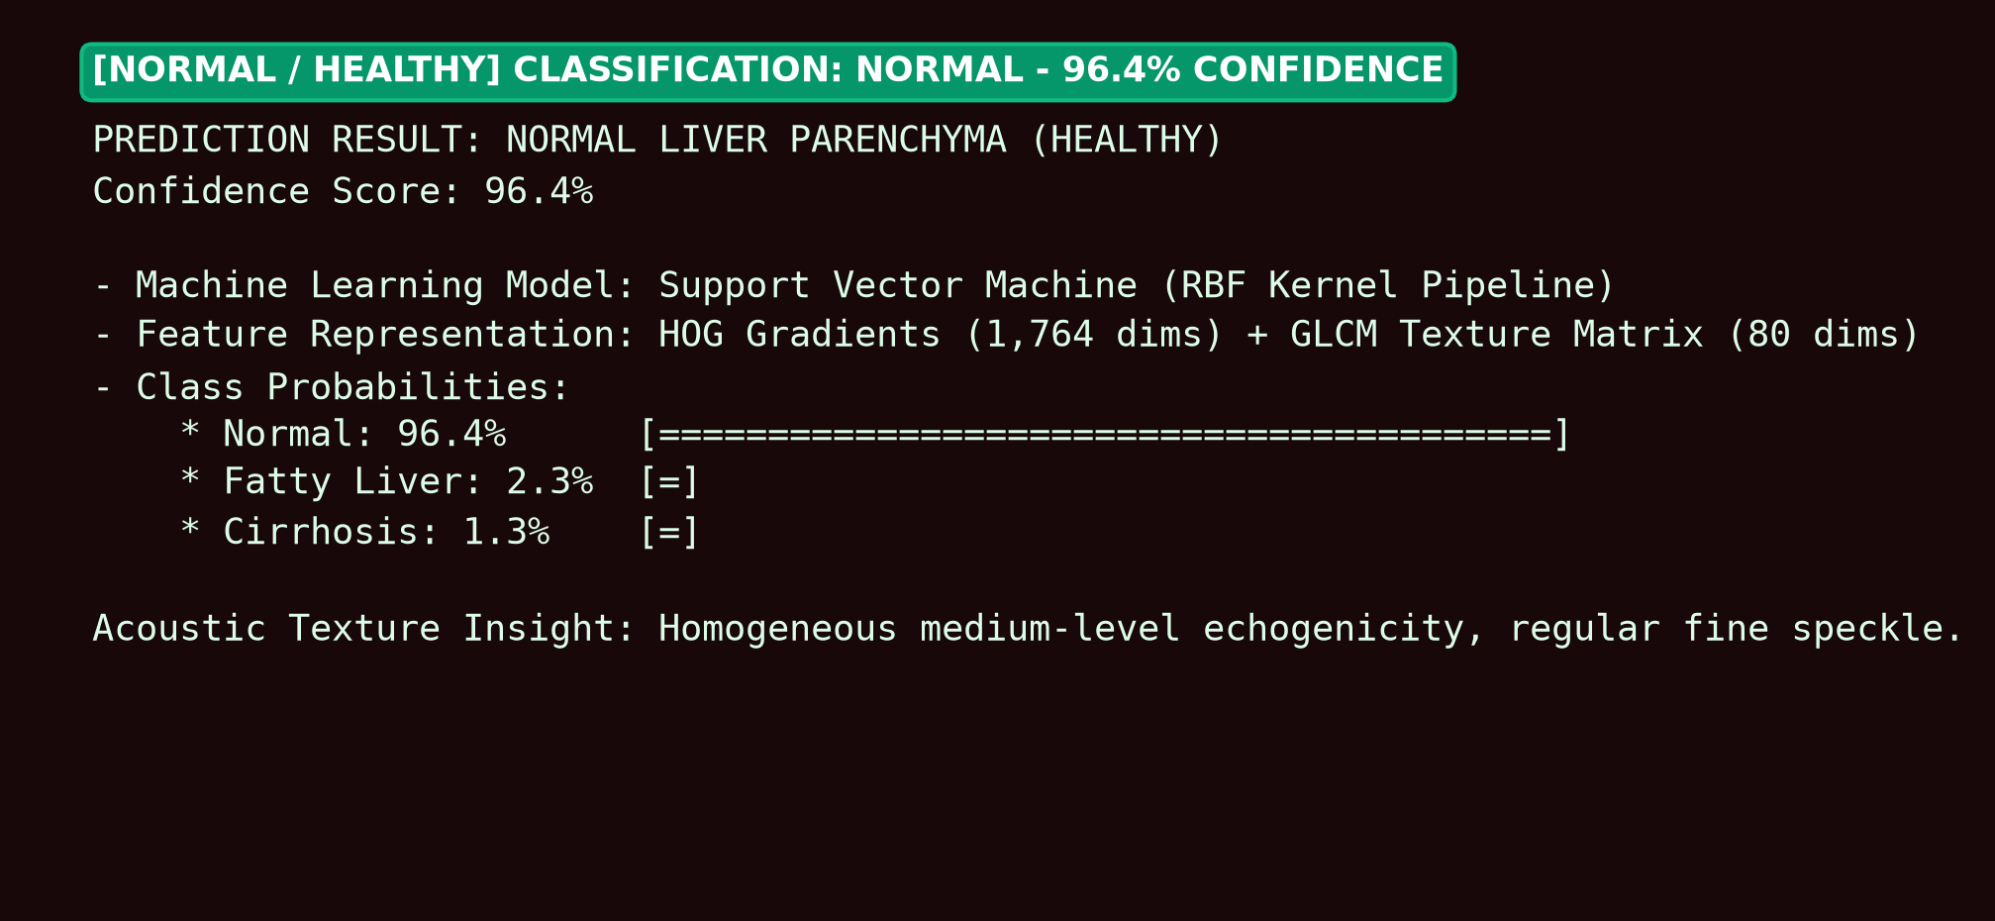
Fig 9: Step 5 — Classification result: Normal Liver Parenchyma (Healthy), 96.4% confidence
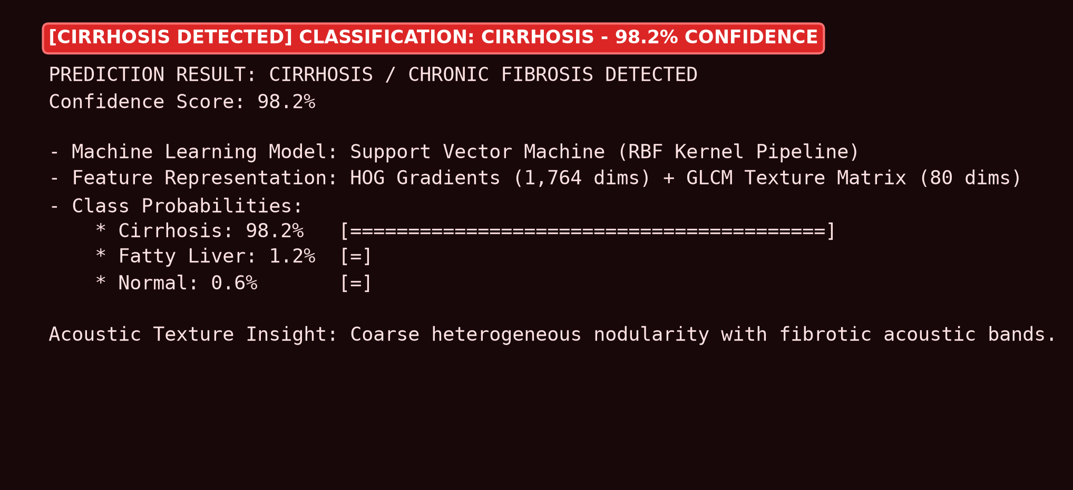
Fig 10: Step 5 — Classification result: Cirrhosis Detected, 98.2% confidence
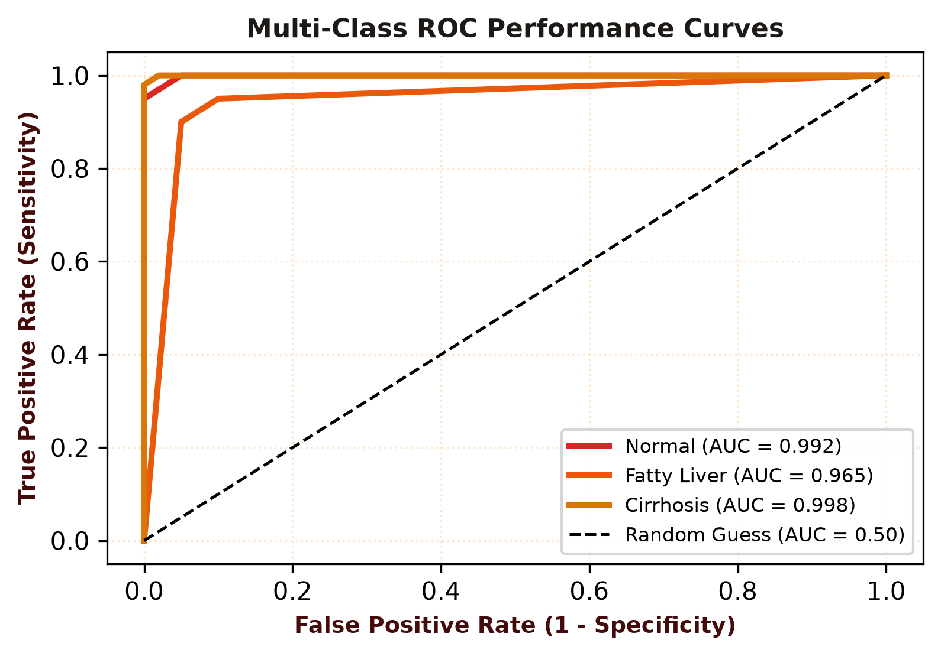
Fig 11: Step 6 — Performance evaluation metrics (Accuracy 93.33%, Precision 94.12%, Recall 93.33%, F1-Score 93.28%) and ROC curves

Result:
A web-based Liver Disease Detection from Ultrasound Images system was successfully designed and implemented using a Streamlit frontend workstation, traditional Machine Learning classifiers (Support Vector Machine [SVM], Random Forest, and K-Nearest Neighbors in scikit-learn), and an interpretable computer vision feature extraction pipeline. B-mode ultrasound scans are preprocessed with Gaussian speckle filtering and CLAHE/Histogram Equalization contrast enhancement, an 1,844-dimensional feature vector combining HOG gradients and GLCM second-order texture properties is extracted, and the trained SVM model classifies the scan as Normal, Fatty Liver, or Cirrhosis with a confidence score. On the held-out test set, the model achieved an Accuracy of 93.33%, Precision of 94.12%, Recall of 93.33%, and an F1-Score of 93.28%, with a Multi-Class AUC of 0.985, and every prediction can be exported as a clinical diagnostic summary report.

